Surrealism

Originating as a literary movement in Paris, Surrealism was initially defined in relation to its literary precursors in the early periodical Littérature (1919-1924), set up by artists and writers including André Breton, Louis Aragon and Philippe Soupault. In 1924, Breton formally enunciated the intentions of Surrealism in the Manifeste du surréalisme (Manifesto of surrealism, 1924). The principle aims of the manifesto were to define Surrealism, declare its members and communicate its methods and intentions. In the same year, writers and artists including Paul Éluard, Louis Aragon and Benjamin Péret, set up the ‘Bureau of Surrealist Research’, an office space in a central Paris location where they aimed to record the forms and expressions of the subconscious mind. These findings were discussed and documented in the pseudo-scientific periodical La Révolution surréaliste (1924-1929). Members of the movement during this period included prominent visual artists such as Max Ernst, André Masson, Hans Arp, Marcel Duchamp and Man Ray, with others joining the movement, such as Salvador Dalí, Francis Picabia, Méret Oppenheim, Yves Tanguy and Alberto Giacometti in the mid-1920s, as Surrealism gained more attention. Other key visual artists associated with the movement include Pablo Picasso and Joan Miró, who never officially joined but exerted influence on Surrealism and adopted surrealist principles in their own work. Surrealism found international success in the 1930s, survived World War II and expired in the 1960s.

Surrealist ideas were influenced by the rising popularity of psychoanalysis in the 1920s and 30s and informed by the ideas of Sigmund Freud. Freud’s theories of the unconscious underpinned Surrealism’s emphasis on the creative possibilities of chance, desire and dream. Rather than create purely objective representations, the surrealists, as ardent disciples of Freudian psychoanalysis, favoured inner experience and the unconscious. Through ‘psychic automatism’ the surrealists created an alternative means of experiencing reality. Automatic writing, the manifestation of this process, superseded the novel as Surrealism’s chosen textual format. Automatic writing was supplemented by the development of new visual techniques in which unusual juxtapositions of objects and images were combined through methods including photomontage and collage, produced by artists like Max Ernst and Dora Maar. Ernst pioneered the ‘automatic’ processes of frottage and grattage. André Masson explored the process of automatism through drawing and paint, Man Ray pioneered experimental photographic techniques, and Dalí realised surrealist ideas through paint, installations and surreal objects. Oscar Dominguez made use of delcalcomania, where paint is applied to paper which is then folded or pressed against another sheet, the resulting image sometimes augmented by drawing. Picasso also employed surrealist themes and techniques in his practice, exploring violence, eroticism and metamorphosis during the 1930s. Aspects of Surrealism can also be traced in the paintings of Miró. After moving to Paris in 1921, Miró’s paintings, such as The Tilled Field (1923-1924), became more imaginative and dream-like, leading Breton to describe him as the ‘most surrealist of us all.’

Surrealism was also underpinned by a strong political ideology. Surrealism emerged out of Dada, a movement whose nihilist, anti-art sentiments were developed as a response to the state of Europe after the Great War. Most surrealists subscribed to a Trotskyist interpretation of Marxism and aligned themselves with Communism. Political, ideological and creative differences led to a number of splits in the group by the time of the ‘Second Manifesto of Surrealism’ in 1930, with a number of members excluded from the group. Dalí was later rejected because of his supposed support of Francisco Franco’s fascist regime in Spain and Georges Bataille and Antonin Artaud also departed from the surrealist group due to ideological differences. Bataille went on to pioneer his own form of dissident Surrealism in the periodicals Documents (1929-1930) and Acéphale (1936-1939).

As the movement gained traction in Paris, their influence took hold in other countries, attracting artists from Belgium like René Magritte, Paul Nougé and Marcel Mariën, with a strand of the movement founded in Czechoslovakia in 1934 by poet Vítězslav Nezval, before reaching the Americas in the early 1940s when many surrealists left occupied France during the Second World War. In Britain the movement came into prominence in the 1930s. Roland Penrose catalysed the development of a British surrealist movement which included Henry Moore, Humphrey Jennings and Eileen Agar. Surrealism (1936), a collection of essays edited by critic Herbert Read was published in 1936 on the occasion of the ‘International Surrealist Exhibition’, which opened at the New Burlington Galleries in London in June 1936. Following David Gascoyne’s A Short Survey of Surrealism (1935), the exhibition introduced Surrealism to a British audience, affirming the existence of a British surrealist group, which had been functioning without formal unity through exhibitions and periodicals from the early thirties. In the Post-War period surrealist activity continued with major exhibitions in Paris and New York, yet was geographically dispersed and often absorbed and overshadowed by developing abstract movements such as Abstract Expressionism.

Scholarly discussions of Surrealism have increasingly departed from a focus on a canonical body of artists and writers (circulating around Breton) to a broader understanding of Surrealism which encompasses marginal figures and the geographical expansion of Surrealism across Europe, Japan and South America. Coupled with a growing awareness of Surrealism’s relationship to politics, science, psychoanalysis and other intellectual impulses of the period, like the occult, such approaches have presented a fuller picture of Surrealism and celebrated its impact on twentieth century thought and culture. Surrealism’s influence on queer artists and theory, for example, have now been explored in the work of artists Claude Cahun and Pierre Molinier. Women artists have also received increasing attention in the context of Surrealism. Historically, the celebration of creativity and its relationship to sexual desire within Surrealism occluded the expression of women who were positioned as muse, femme fatale, or femme enfant. Women were often not members of the official group, rather, contributed as partners or creative subjects and were largely excluded from official activities. Correlating with the rise of feminism and the establishment of a feminist art history, Xavière Gauthier’s Surréalisme et Sexualité (1971) sparked a series of critical responses to this male dominance. A striking amount of critical attention has since been devoted to the role of sexuality and desire in surrealist art. Landmark studies, which sought to rectify the marginalisation of women in surrealist practice, such as Whitney Chadwick’s Women Artists and the Surrealist Movement (1985) and the exhibition Mirror Images: Women, Surrealism and Self-Representation (1998) and its accompanying literature, have opened up new readings of the role of women in Surrealism. Female artists such as Dorothea Tanning, Dora Maar, Claude Cahun, Leonora Carrington, Leonor Fini, Remedios Varo, Meret Oppenheim, Valentine Penrose and Lee Miller are now celebrated as artists on the own terms.

The word ‘surreal’ is now commonly used as an adjective to describe the unusual or unexpected. Despite the term’s detachment from the original movement, methods and ideas generated in the context of Surrealism have endured and are recognisable in contemporary art practice. Artists including Louise Bourgeois and swathes of YBAs adapted methods and ideas pioneered by surrealist artists, such as the objet trouvé (found object). Surrealism’s contribution to the development of experimental cinema also endures with the work of directors like Luis Buñuel continuing to have influence today. After Breton’s death in 1966, many believed that Surrealism, as an official movement, was over. Yet, collectives which developed from the Parisian origins and identify themselves as surrealist are still active across the U.K in Leeds, London and Birmingham, and in Czechoslovakia and Chicago.

References and further reading:

Ades, D. (1978) Dada and Surrealism Reviewed (exh. Cat), London: Arts Council of Great Britain.

Angliviel de la Beaumelle, A. (1991), André Breton: La beauté convulsive, Paris: Éditions du Centre Pompidou.
Bate, D. (2004) Photography and Surrealism, London: I B Tauris
Breton, A. (1928) Le surrealisme et la peinture, Paris: Gallimard. (republished by Museum of Fine Arts, Boston (2002)
Breton, A. (2010) Manifestoes of Surrealism, trans., Richard Seaver and Helen R. Lane, Ann Arbor: University of Michigan Press.

Chadwick, W. (1985) Women Artists and the Surrealist Movement, London: Thames and Hudson.
Gauthier, X. (1971) Surréalisme et Sexualité
Lewis, H. (1990), Dada turns red: the politics of Surrealism, Edinburgh: Edinburgh University Press
Matheson, N. (Ed.) (2006): The Sources of Surrealism: Art in Context, Aldershot: Lund Humphries.
Mundy, J. (2001), Surrealism: Desire Unbound (Exh Cat.) London: Tate Gallery
Read, H. (1936) ed., Surrealism, London: Faber & Faber.
Richardson, M. (2006), Surrealism and Cinema, London: Berg
Spies, W. (1991), Max Ernst: Collages: The Invention of the Surrealist Universe, London: Thames & Hudson

Centre for the Study of Surrealism and its Legacies. http://www.surrealismcentre.ac.uk/
Web site of a collaborative project involving Manchester University, University of Essex and Tate. Includes free access to an online journal that publishes contemporary surrealist scholarship.

Images
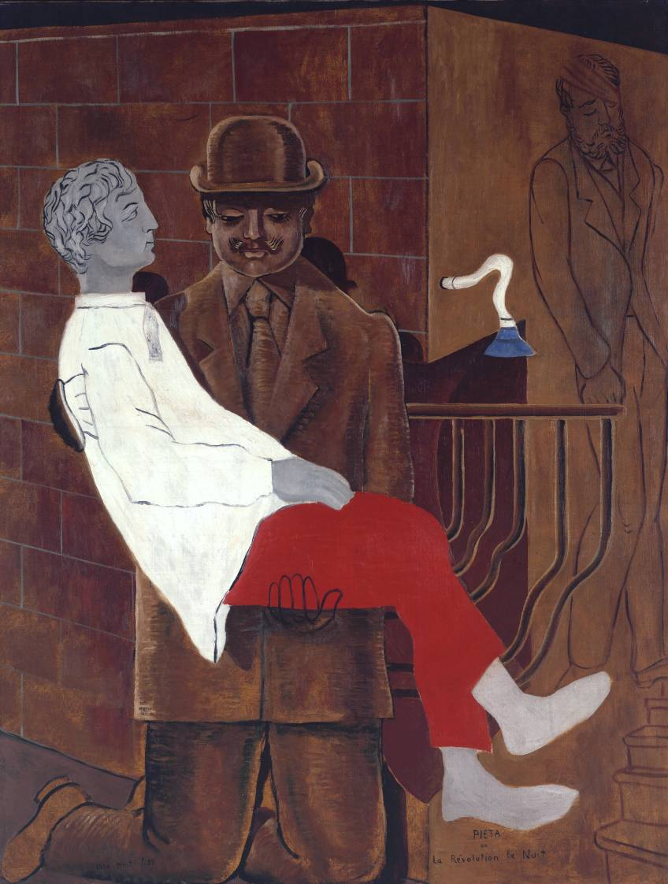

Max Ernst Pieta or Revolution by Night (1923) Oil on canvas
http://www.tate.org.uk/art/artworks/ernst-pieta-or-revolution-by-night-t03252
© ADAGP, Paris and DACS, London 2002
License this image
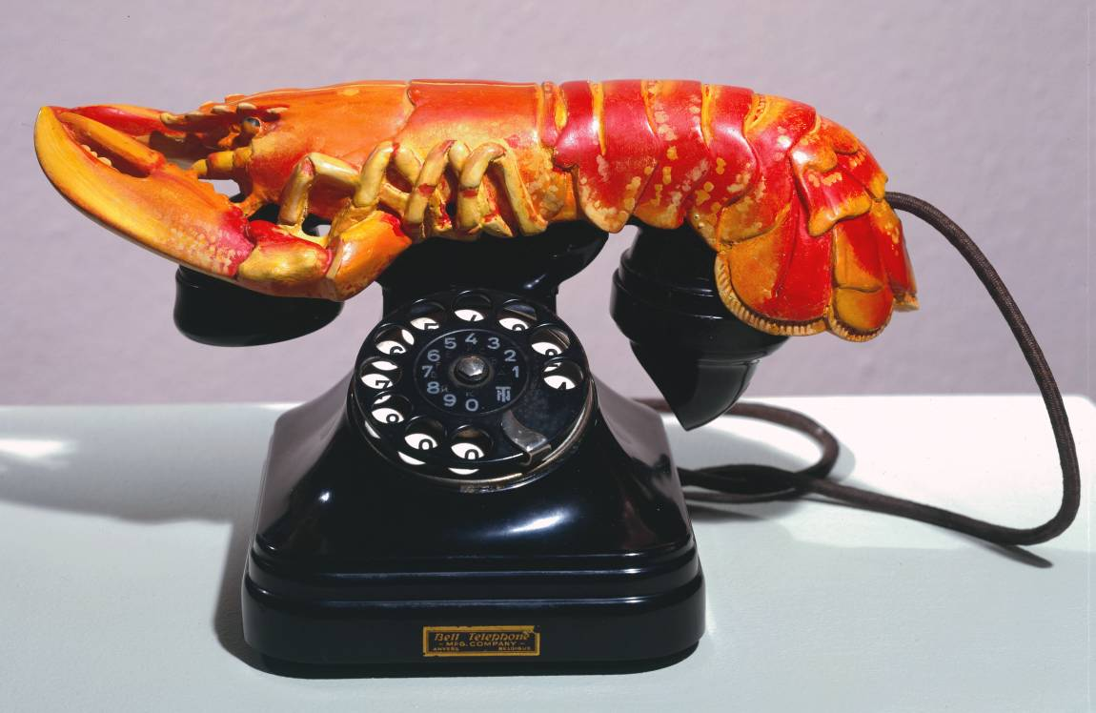

Salvador Dali Lobster Telephone (1936) Steel, plaster, rubber, resin and paper.
http://www.tate.org.uk/art/artworks/dali-lobster-telephone-t03257
© Salvador Dali, Gala-Salvador Dali Foundation/DACS, London 2002
License this image
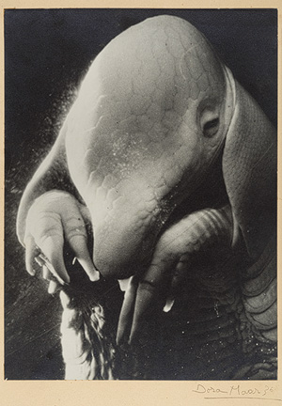
Dora Maar Pére Ubu (1936) Gelatin silver print
http://www.metmuseum.org/collection/the-collection-online/search/286239
Rights and Reproduction: © 2011 Artists Rights Society (ARS), New York

